Name _______________________________
Destructive & Constructive Processes Study Guide
- A destructive process …  tears down | - A constructive process….  builds up
- ___________ is the dropping or depositing of sediments or soils in a new location by water, wind or ice.  deposition | - A sandbar is an example of  deposition
- Small islands can form during the constructive process called  deposition | - Seashells on a beach are an example of  deposition
- A low plain that forms where a river enters the ocean or lake is a(n)  delta | - The process that breaks down rocks into smaller pieces is called  weathering
- Which process breaks rock into smaller pieces called sediment without changing the type of rock?  mechanical/physical weathering | - The moving of sediments and soil to a new location by wind, water, ice, and gravity is called  erosion
- Which processes form a sea stack?  weathering and erosion | - Which can cause weathering, but NOT erosion?  chemicals in rocks reacting with water
- Here are the instructions for demonstrating how erosion can change a surface feature.  Create a landform in a flat pan.  Pour water over the landform.  Observe how the shape of the land changed after pouring the water.  Record your observations. | - Which most likely carved out a canyon’s steep sides?  a river wore away and eroded the rock
- Mount Everest is the tallest mountain in the world above sea level. It is about 8,850 m high. Brasstown Bald, the tallest mountain in Georgia, is about 7,392 m lower. Subtract the two numbers to find the height of Brasstown Bald. | - Each of these sentence describes the impact organisms can make on Earth’s surface.  ____ Lichens and moss make chemicals that soften  rocks and break them into smaller pieces  ____ Large tree roots break apart rocks  ____ Bacteria and fungi change rock into soil  ____ Insects and earthworms add nutrients to the  soil and break apart soil pieces

Weathering | Erosion | Deposition
27. Flood water pounding  against a canyon wall  and wearing it down | 28. A mudslide flowing  down a steep hill | 29. Waves dropping sand  on the beach
30. Water getting into  cracks, freezing, and  breaking the rocks apart | 31. Rain washing away  soil from a hillside | 32. Layers of sediment  collecting at the bottom  of the ocean
33. Wind blasting sand  at rock and carving  out arches | 34. Glaciers scraping  rocks across the  earth’s surface | 35. Deltas forming at the  mouths of rivers

The following surface features are created by destructive processes. Match each feature with the process that created it.

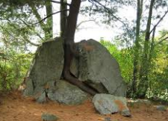
- a tree growing through* * An example of mechanical weathering is a tree
a rock growing through a rock

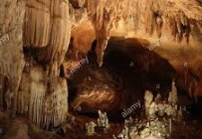
- a limestone cave * * Chemical weathering can create a limestone cave

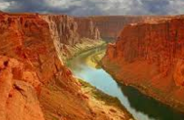
- a canyon * * Rapid erosion in a river valley creates a canyon

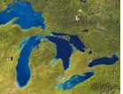
- the Great Lakes * * Erosion from a glacier carved out the Great Lakes

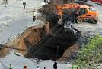
- a sinkhole * * The rock above a cave collapses and causes a sinkhole

The following surface features are created by constructive processes.
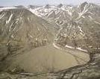
- an alluvial fan * * a river rushes down a steep slope and deposits its
sediments on a flat plain to create an alluvial fan

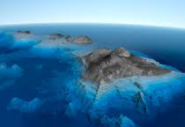
- the Hawaiian Islands * * huge deposits of lava created shield cones that
formed the Hawaiian Islands
form

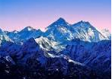
- the Himalayan Mountains * * Huge sections of the Earth’s crust, called plates moved
into each other to create the Himalayan Mountains
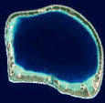
- an atoll * * Deposits of coral skeletons called coral reefs form in a
ring shape to create an atoll

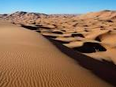
- a sand dune* * wind blows sand until it hits an obstacle and piles up to
create a sand dune

