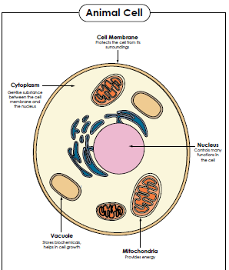
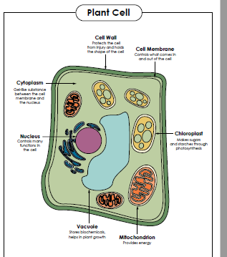
Name: ______________________ Study Guide for Cells
Be able to draw a plant and animal cell and label these 3 things in both: cell membrane, nucleus, cytoplasm and the cell wall and chloroplasts in the plant cell only. Animal cells do not have a cell wall or chloroplasts.

Be able to fill in this chart
Organelle | Type of cell | Function | Hint | Compare to school
Cell membrane | Both plant and animal cells | Flexible structure that holds all the cell parts inside and decides what comes in and out | Re”mem”ber to use your brane (brain) and close the door | Walls and doors of the school
Cell wall | Plant only | Provides extra structure and strength to the cell | Brick wall | Fence surrounding the school
Cytoplasm | Both plant and animal cells | Thick liquid where cell parts float | Cyto-pool | Tile floor – fills all the space inside and supports all the desks
Nucleus | Both plant and animal cells | Controls the cell and contains the DNA of the cell | Nucle-boss | Principal of the school because she is in charge
Chloroplasts | Plant only | Food producers; use sunlight to make food through photosynthesis | A blast of light creates a photo of food | Cafeteria where they make food for the students

Plant cells have chloroplasts and animals cells do not. Plant cells need chloroplasts to make food through photosynthesis. Animals do not use photosynthesis because they find food and eat it with their mouths.
Microscopes allow us to see the organelles that make up cells. A hand lens does not magnify a cell enough to see the organelles.
All living things are made of cells. Living things eat, get rid of wastes, grow, and reproduce. Identify if each thing has cells (because it is a living thing) or does not have cells (because it is non-living).
desk | dog | rock | tree
jellyfish | cloud | soil | house
toad | rose | mushroom | volcano

