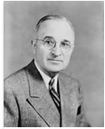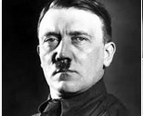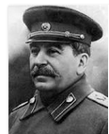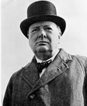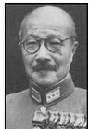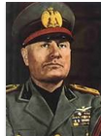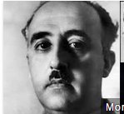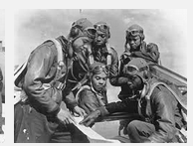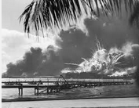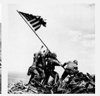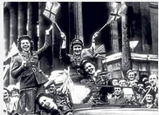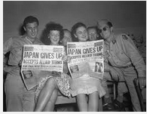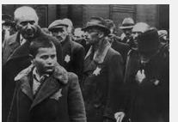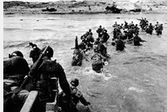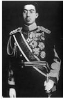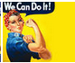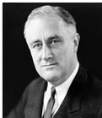

Franklin D. Roosevelt | Harry Truman | Adolf Hitler | Joseph Stalin
Winston Churchill | Hideki Tojo | Benito Mussolini | Francisco Franco
Emperor Hirohito | “Rosie the Riveter” | Tuskegee Airmen | Bombing of Pearl Harbor
Iwo Jima | D-Day | V-E Day | V-J Day
The Holocaust
Americans defeat Japanese forces to occupy island of Iwo Jima
Elite African American Airmen | systematic slaughter of millions of Jews | unprovoked aerial attack on American soil by Japanese | Italian Dictator
U.S. & Great Britain invaded occupied France – largest sea-to-land invasion in history | Germany defeated – victory in Europe | Japan surrenders – victory over Japan | Spanish Generalissimo
British Prime Minister | Japanese General | Japanese Emperor | represented American women working in defense factories
U.S. President | U.S. President | German Dictator | Russian Dictator

